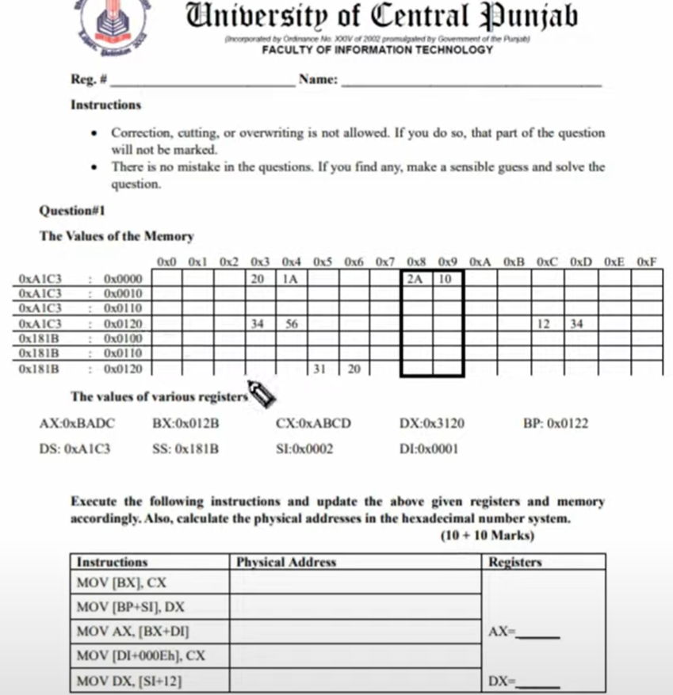P1 MOV [BX] , CX THIS offset address BX = 0X 012B
A1C3E
A1D5C
182D4
A1C3F
A1D5B
CD
AB
CD|AB
20|31
LOGICAL address 0XA1C3 : 0X 012B
NOW FOR ADDING FOR THE PHYSICAL ADDERSS THE SEGMENT AND OFFSET ADDERSS
A1C30
+012B
_A1D5B_ ANS

P2 MOV [BP+SI] , DX THIS offset address BP = 0X0122 + SI = 0X0002 = NET = 0X0124
LOGICAL ADDERSS = 181B : 0X0124
PYHSICAL ADDDERSS = 181B0
0124
182D4 ANS
P3 MOV AX, [BX+DI] THIS offset address BX =0X012B + DI = 0X0001 h = NET = 0X012C
LOGICAL ADDERSS = A1C3 : 012C
PYHSICAL ADDDERSS = A1C30
_012C_ AH | AL
A1D5C = Ans AX = 34 | AB
THIS IS HOW WE READ FORM THE MEMORY

P4 MOV [DI+ 000Eh] , C X THIS offset address 0X0001 + 000E h = Net = 0x000f
LOGICAL ADDERSS = A1C3 : 000f
PYHSICAL ADDDERSS = A1C30
000f
A1C3F ANS THIS OUR PHYSICAL ADDERSS

P4 MOV DX [SI + 12] THIS offset address [ SI = 0X0002 +12 ] = NET OFFSET DX [0X000E h]
LOGICAL ADDERSS = A1C3 : 0X000E h
PYHSICAL ADDDERSS = A1C30
_000E_
A1C3E
DH | DL
DX = [ CD | -- ] THIS WILL BE IN THE MEMORY
THIS IS HOW WE READ FORM THE MEMORY
QUESTION 2 ...
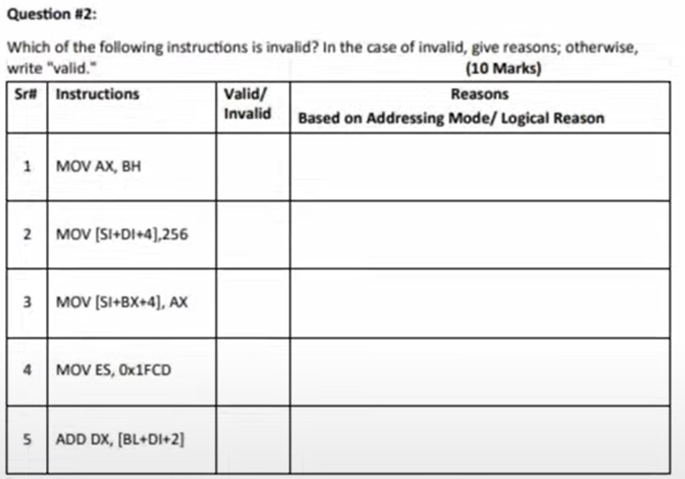
INCORRECT SIZE AX , BH THAT WHY INCORECT IN FUNCTION
BOTH PIONTER S OF SAME DATA SEGMENT THAT’S
WHY IT COULD NOT WORKPROPEERLY

BASED – INDEXED RELATIVE REGISTER IS USED HERE
SEGMENT registers can’t take direct values that ,why it could not be able to run

Indexed – based relative registers mode is used here

R
X
R
X
X
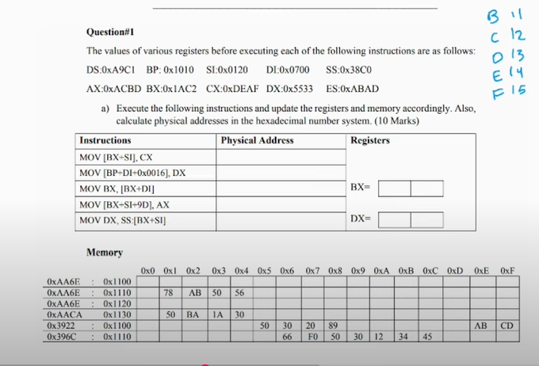
Assignment # 2
QUESTION 1
P1 MOV [BX + SI ] , CX THIS offset address BX + SI = 1AC2 + 0120 = NET OFFSET = 1BE2
33| 55
34| 12
BD| AC
||
AF |DE
AB7F3
1A | BA
LOGICAL address 0XA9C1 : 0X 1BE2
NOW FOR ADDING FOR THE PHYSICAL ADDERSS THE SEGMENT AND OFFSET ADDERSS
A9C10 | AB7F2
+1BE2 | - 1110
_AB7F2_ ANS | = NET = AA6E2

P2 MOV [BP +DI +0X0016 h] , CX THIS offset address BP + DI = 0X1010 + 0700 +0016 = NET OFFSET = 1726h
LOGICAL address 0X38C0 : 0X 1726h
NOW FOR ADDING FOR THE PHYSICAL ADDERSS THE SEGMENT AND OFFSET ADDERSS
38C00
+1726
_TEXT_ ANS PHYSICAL ADDRESS

P3 MOV BX , [BX + DI] THIS offset address [1AC2 + 0700] = NET OFFSET DX [0X21C2 h]
LOGICAL ADDERSS = A9C1 : 0X21C2 h
AACA0 PYHSICAL ADDDERSS = A9C10
1130 _21C2_
ABDD0 PYHSICAL ADDDERSS ABDD2 PYHSICAL ADDDERSS
0X2 COLOUMS
BH | BL
BX= [1A | BA ] THIS WILL BE IN THE MEMORY
THIS IS HOW WE READ FORM THE MEMORY
R
X
P4 MOV [ BX +SI+9D ] , AX THIS offset address [ 1ABA + 0120 +9 ] = NET = 0X1BE3
DS : OFFSET
LOGICAL ADDERSS = A9C1 : 0X1BE3
PHYSICAL ADDRESS = A9C10
BOTH SAME METHODES 1BE3
AB7F3 AB7F3 THIS IS THE PHY ADDERSS AB7F3
___-1110___ ___--AA6E0___
AA6E3 1113
P5 MOV DX, SS :[ BX + SI ] THIS offset address [ 1ABA + 0120 ] = NET = 0X1BDA h
LOGICAL ADDERSS = 38C0 : 1BDA
PHYSICAL ADDRESS = 38C00
3A7DA _1BDA_
__- 1110 ___ THIS FOUND AT THIS OFFSET ADDERSS 3A7DA
396CA
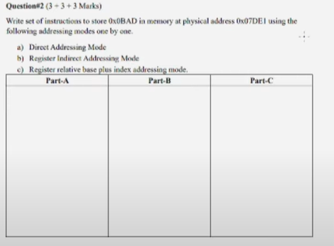
2nd question

DA mode IDA mode
MOV AX , 0X0001 h ; SHIFT LEFT THEN MOV AX , 0X0001 h ; SHIFT LEFT THEN
MOV DS , AX MOV DS , AX
MOV [0X 7DD1] , 0X 0BAD MOV SI , 0X 7DD1
MOV [SI] ,0X 0BAD
* R B I MODE
MOV AX , 0X0001h ; SHIFT LEFT THEN
MOV DS , AX
MOV BX ,0X 1110
MOV SI , 0X 6CC0
MOV [ BX + SI + 0X0001 ] , 0X0BAD
WITH DIIFRENT METODES
MOV AX, @DATA
MOV DS,AX
MOV AX ,0X0001h
MOV DS , AX
MOV BX ,0X1110
MOV SI , 0X6CC0
MOV [ BX + SI + 0X0001],0X0BAD

; With an other way
MOV AX ,0X0000h
MOV DS , AX
MOV BX ,0X1
MOV SI , 0X7DE1-2
MOV [ BX + SI + 0X0001],0X0BAD
MOV BX,[ BX + SI + 0X1]
MOV VAR ,BX

QUESTION 3
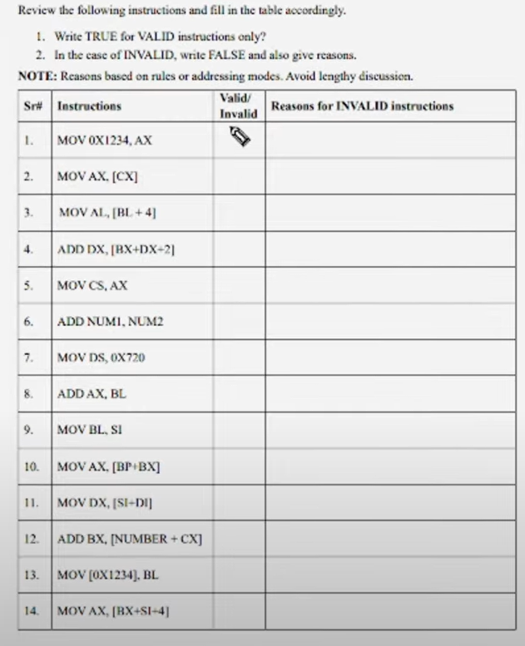
VALID
INVALID
INVALID
VALID
INVALID
INVALID
INVALID
invalid
invalid
invalid
invalid
INVALID
VALID
VALID
WE CAN OVER RIGHT THE value = AX
we should use the pointers like BX , SI , DI
/
because the absence of the [ bx ] | / [ bl] X
memory can be added to the register
because code segment is not used as a register to store the values like data segment or any other
two variables can’t be added VAR ARE USED AS MEMORYS AND MEM AT BOTH SIDE is not ALLOWED
Because it takes registers only but can not values directly
due to different size of the both registers
due to different size of the both registers AND POINTER
we can’t use the based reg and both index ed registers to gather
we can’t use the based reg and both index ed registers to gather
because we can’t right the any variable in the memory
THIS HOW CAN overwrite into the memory
Assignment # 2
QUESTION 1
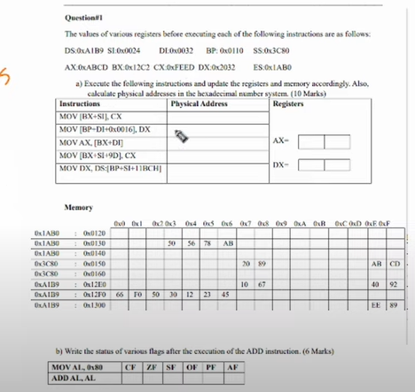
A2E76
3C958
A2E84
A2E7F
A2E80
F0 |FE
FE
ED
23 | 12
23 |12
32 | 20
ED | FE
P1 MOV [ BX + SI ] , CX DS : [12C2 + 0024 ] = NET ADDRESS = 12E6
L . A = A1B9 : 12E6
P. A = A1B90
+12E6
A2E76 = P.A
PART = : 2
MOV [ BP + DI + 0X0016 ] , DX [0110+ 0032+ 16 ] NET ADDERSS = 0X0158
L . A 3C80 : 0158
P. A = 3C800
+0158
P . A = 3C958
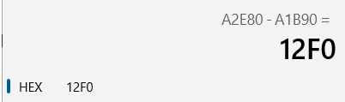
PART = : 3
MOV AX , [ BX + DI ] = [ 12C2 + 00032 ] = NET ADDERSS = 0X 12F4
L . A = A1B9 : 12F4
P . A = A1B90
+12F4
A2E84 P . A
PART = : 4
MOV [ BX + SI + 9D ] , CX =[12C2 + 0024 + 9 ] = NET . A = 12EF
L. A = A1B9 : 12EF
P. A A1B90
+12EF
A2E7F = P . A
PART = : 5
MOV DX , DS [ BP + SI + 11BC H ] = NET. A =[ 0110 + 0024 + 11BC ] = 12F0
P.A = A1B90
+ 12F0
A2E80 P . A

